|  |  |  |  |  |  |  |
| --- | --- | --- | --- | --- | --- | --- |
| VILNIAUS KOLEGIJA  UNIVERSITY OF APPLIED SCIENCES  FACULTY OF ELECTRONICS AND INFORMATICS  Image result for viko logo | | |  | | | VILNIUS COLLEGE  Image result for viko logoFACULTY OF ELECTRONICS AND INFORMATICS |
|  | | |  | | |  |
| **SMART DEVICE SENSORS PROGRAMMING** | | |  | | | **INTRODUCTION TO INFORMATICS** |
| LABORATORY WORK  LABORATORY WORK NR.: 5  6531BX028 PI18E | | |  | | | PRACTICAL ASSIGNMENT  SPOTIFY USER MANUAL  6531BX028 PI18E |
| STUDENT | DŽIUGAS PEČIULEVIČIUS | STUDENT | | DŽIUGAS PEČIULEVIČIUS |
| (SIGNATURE)  3/5/2021 | | |  | | | LECTURER |
| LECTURER | SIMONAS ČESNAUSKAS | (SIGNATURE)  10/17/2018 | | VIRGILIJUS KUKLIERIUS |
| (SIGNATURE)  3/5/2021 | | |  | | | 2018 |

2021

Tasks:

1. Use the Arduino UNO controller description to determine which ports can be used as digital control outputs.
2. Set the selected controller port to output digital control information.
3. Create functions that output logic 0 and logic 1 to the selected controller port.
4. Identify and implement at least three pieces of information through a LED indicator.
5. Write conclusions about the possibilities of digital information output using controllers.
6. Determine how many and which maximum digital outputs can be used to control the LED indicators and create a LED indicator control model with six LEDs and draw a connection diagram.
7. Create a multi-point LED indicator control program for an Arduino controller that outputs information to LED indicators using variables.
8. Write conclusions about the control possibilities of several point indicators with the Arduino controller.
9. Write general conclusions about the application possibilities of the Arduino controller.

Answers:

1. Arduino UNO has 20 input/output pins. 14 of them are digital and 6 are analog. 6 out of 14 digital pins are PWM (they have ~ sign next to the output number).
2. The code can be copied below:
3. int LEDB_PIN_VIN = 13;
4. void setup() {
5. // code setup to run once
6. pinMode(LEDB_PIN_VIN, OUTPUT);
7. }
8. void loop() {
9. // main code which runs repeatedly
10. digitalWrite(LEDB_PIN_VIN, HIGH); // turn LED on (high level voltage)
11. delay(1000);                      // wait for a second
12. digitalWrite(LEDB_PIN_VIN, LOW);  // turn LED on (low level voltage)
13. delay(1000);                      // wait for a second
14. digitalWrite(LEDB_PIN_VIN, HIGH); // turn LED on (high level voltage)
15. delay(1000);                      // wait for a second
16. digitalWrite(LEDB_PIN_VIN, LOW);  // turn LED on (low level voltage)
17. delay(1000);                      // wait for a second
18. digitalWrite(LEDB_PIN_VIN, HIGH); // turn LED on (high level voltage)
19. delay(1000);                      // wait for a second
20. }

6.

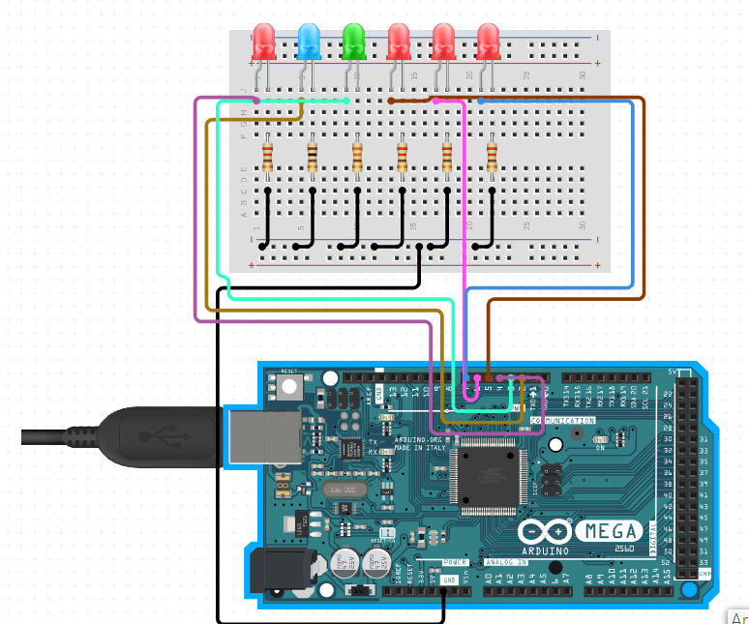

1. We can make Arduino behave how we want it. We can read inputs –LEDs on a sensor, we can write a program and make it behave how we want it and whats connected to it.